**CSE 460 LAB EVALUATION 1**

**ID:21301610**

**Name: SHIHAB MUHTASIM**

**Circuit Diagram:**

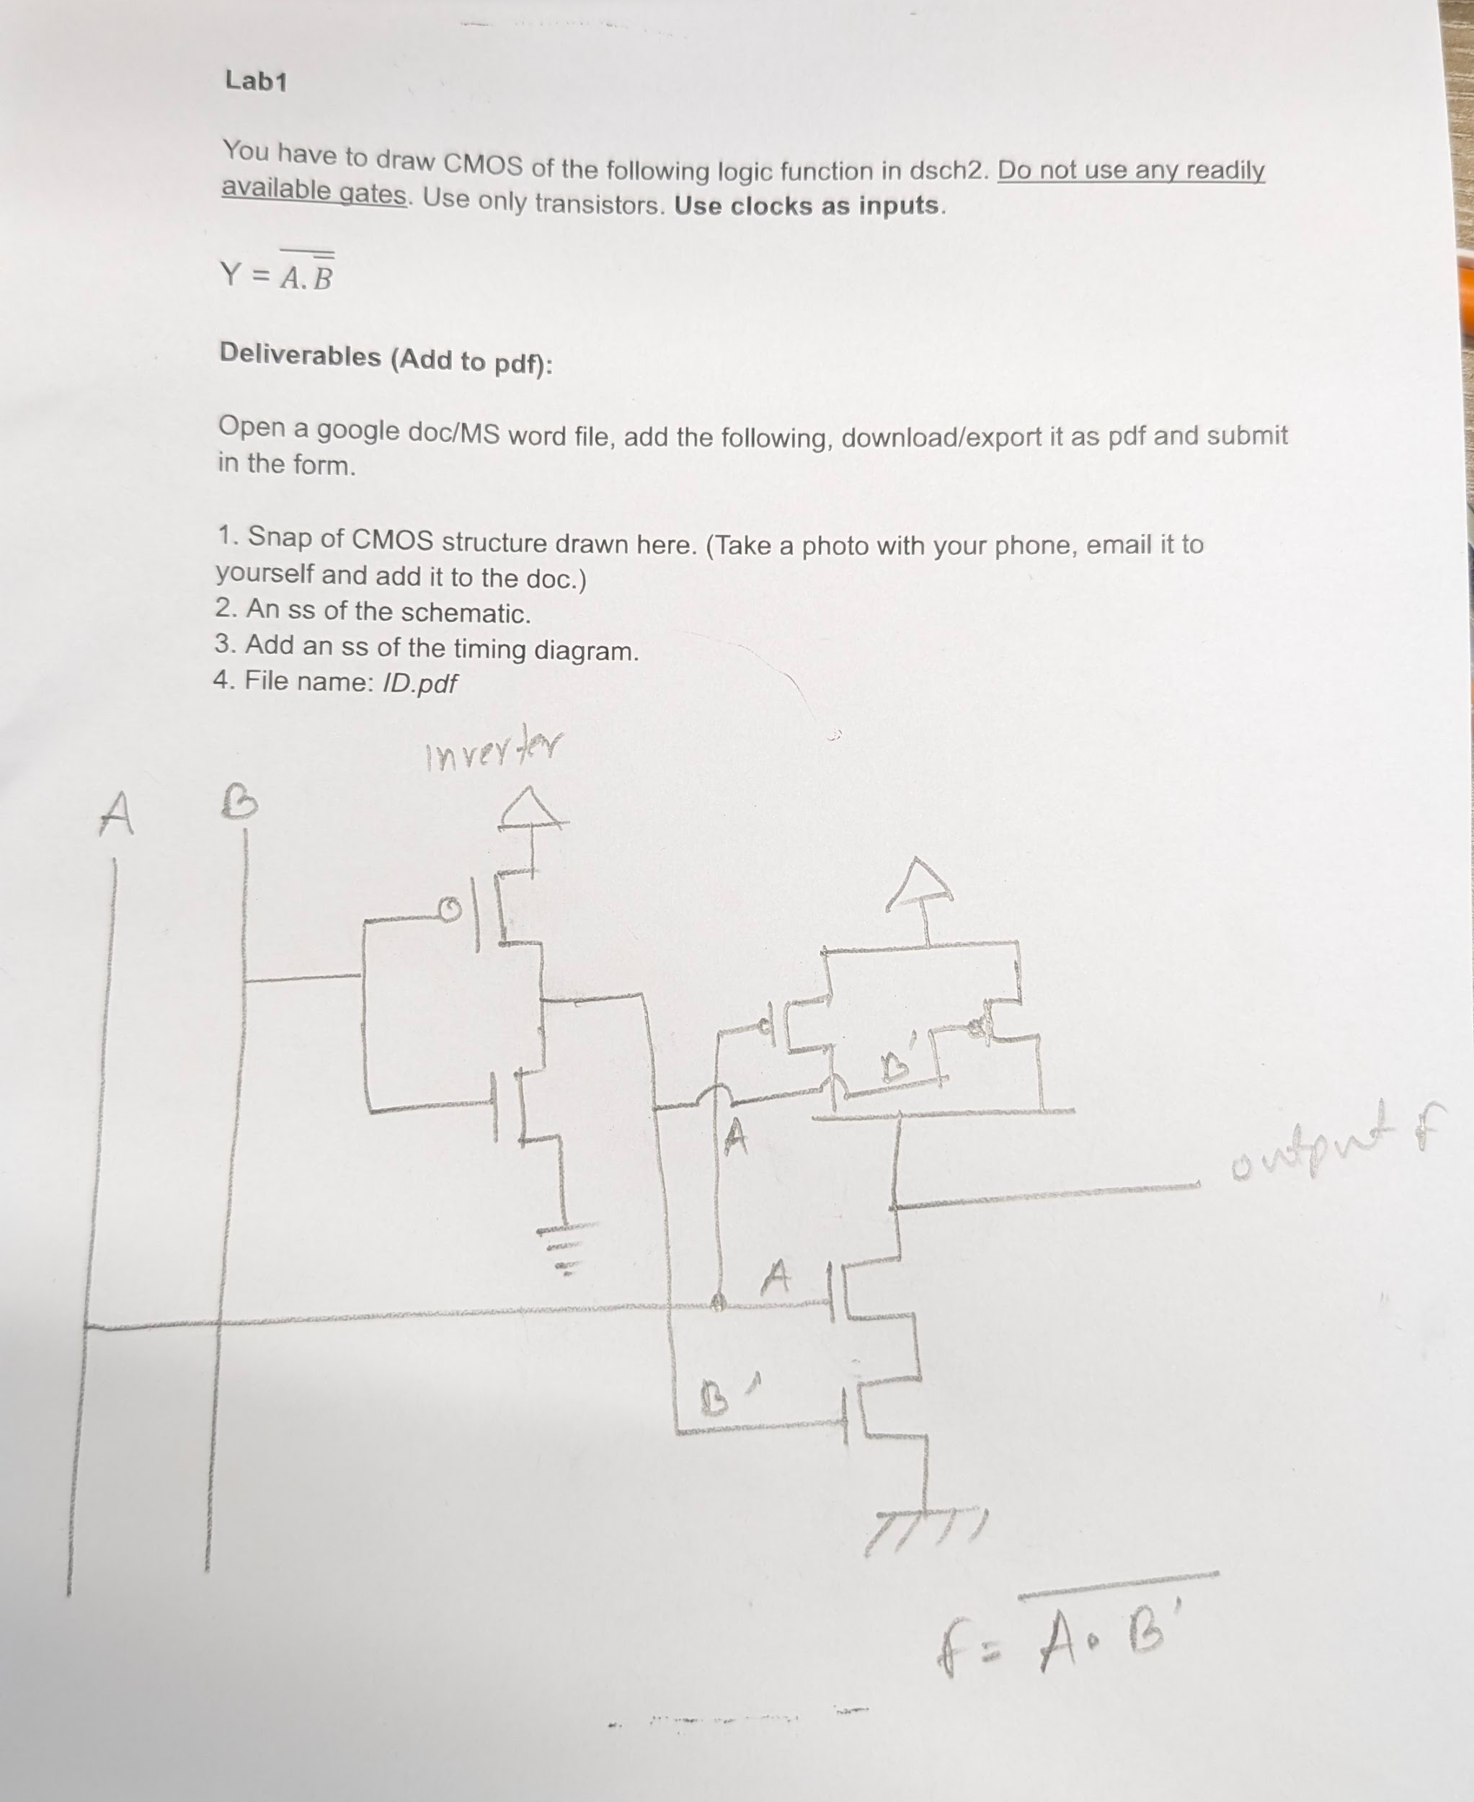

**INVERTER:**

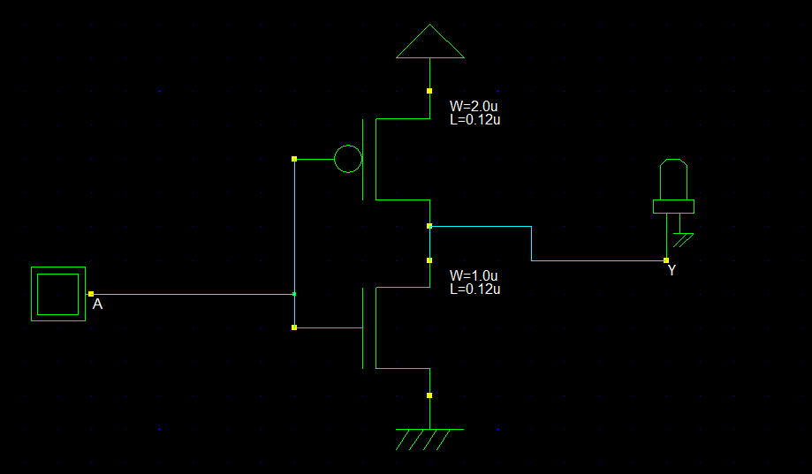

**MAIN CIRCUIT:**

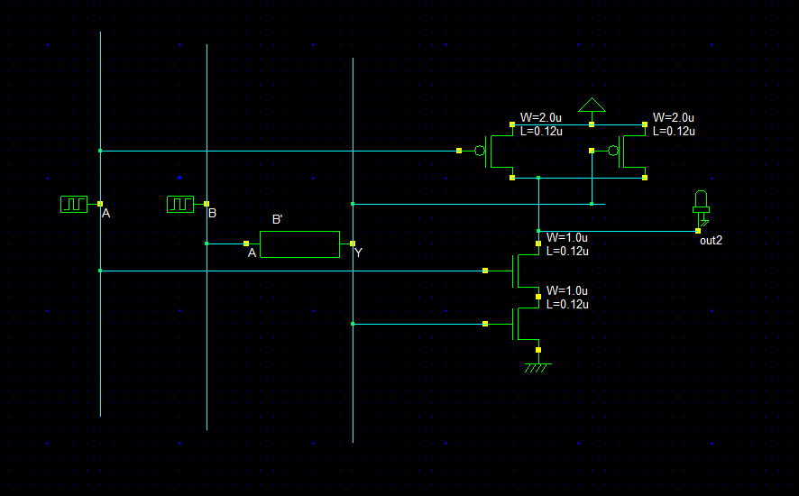

**TIMING DIAGRAM:**

